/\* Online C Compiler and Editor \*/

#include <stdio.h>

char \*f();

char a='a';

int main(int argc,char\*argv[]){

char\* temp=f();

printf("%s",temp);

return 0;

}

char\*f(){

return &a;

}

Output:a

2)#include <stdio.h>

#include <stdlib.h>

int main(int argc, char \*argv[]) {

char temp[20];

gcvt(23.45, 2, temp); // Converts 23.45 to a string with 2 significant digits

printf("%s", temp); // Prints the string stored in temp

return 0;

}

Output:23

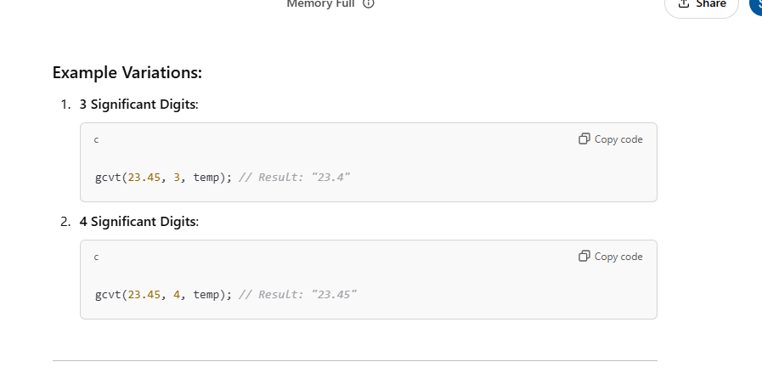

3)#include <stdio.h>

#include <stdlib.h>

int main(int argc, char \*argv[]) {

char temp[20];

gcvt(23.45, 2, temp); // Converts 23.45 to a string with 2 significant digits

printf("%s", temp); // Prints the string stored in temp

return 0;

}

Output:23

int main(int argc,char\*argv[]){

int a=atoi("100");

printf("%d",a);

}

Answer:100

4)int main(int argc,char\*argv[]){

if (printf("cppbuzz.com")) { // Add parentheses around printf

printf("cppbuzz.com"); // Add parentheses and a semicolon

}

}

Output:2

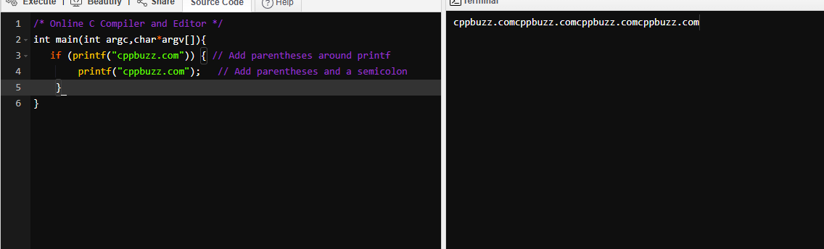

5) #include <stdio.h>

int main(int argc, char \*argv[]) {

int x = 10; // Declare and initialize x

{ // Start of a new block

int x = 0; // Declare a new x (shadows the outer x)

printf("%d", x); // Prints the inner x (0)

}

return 0; // End of main function

}

Output:0